Name_____________________________ 5th Grade Math 4 Today Week #10
Monday (A.5.5.1)
Solve the equation for w.  11 − 7 = w | Jared ate 3 servings of a fruit snack in one day. He wrote the equation shown to find c, the total number of calories in each serving of the fruit snack.  3 ⋅ c = 135  What is the value of c? | Each smiley face represents the same number.  What number does each equal? | The scale below is balanced.  If one = 1, what is the value of one ?
Solve each.  8 x 3 = | 5 x 5 = | 6 x 8 = | 9 x 6 =

Tuesday (G.8.5.3)
Jamarian, Levi, and Winston are competing with each other to see who is best at throwing darts. They have played several games and decided that whoever hits the center in the final round is the “Dart Champion.” According to the figure below, who should be named “Dart Champion?”  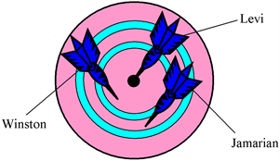 | Name the diameter of the circle below.  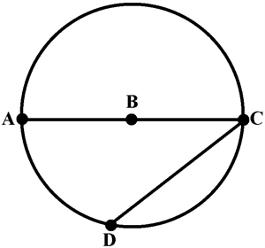 | Marissa got a new bike for her birthday. She decided to paint alternating spokes on her bike. What is another name for the spoke on Marissa’s bike? | Quentin wrote a fable for his 5th grade class. In his story an ant walked across the moon as shown in his illustration.  In relation to the circle, what is represented by the line he walked?
Wednesday (M.13.5.1)
It is Thursday, July 27, and Corey has begun collecting his school supplies. School begins two weeks from today. What day does Corey start back to school? (July has 31 days.) | Kyla is going to Skate Night with her friends. Her dad told her to be home at 8:15 p.m. If she leaves her house at 5:54 p.m., how long will it be before she has to be home? | Houston and Clifford are going to see a movie that starts at 6:55 p.m. The movie is 1 hour and 53 minutes long. What time will the movie end? | Ashley's last day of school for Christmas vacation is Friday, December 20. Students are to report back on Monday, January 6. How many days will Ashley be out of school? (Hint: December has 31 days.)

Thursday (DAP.15.5.2)
What is the range of the data shown below?  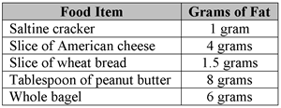 | Soccer is the world’s most popular sport. The table lists the records of five World Cup winners.  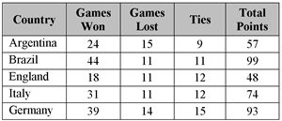  What was the median number of total points scored by these teams? | What is the mode of the following set of numbers?  5 , 6 , 9 , 2 , 2, 5 , 11 , 4 , 6 , 5 | Use the stem and leaf plot below to find the median of the data.  