Name__________________ 5th Grade Math 4 Today Week #12
Monday (NO.1.5.1d)
Andrew has 9 pets. He has 3 snakes and 6 fish.What is the ratio of snakes to fish? | Abby has 15 stuffed animals. She has 8 bears and 7 elephants. What is the ratio of elephants to the total number of stuffed animals? | Sam has a total of 15 video games. He has 5 fighting games and 10 racing games. What is the ratio of racing games to fighting games? | Emma has 8 pets. She has 3 dogs and 5 cats. What is the ratio of cats to pets?
Solve each.  7 x 7 = | 4 x 4 = | 9 x 9 = | 6 x 6=

Tuesday (NO.3.5.5c)
Mrs. Melton drew the fractions below on the chalkboard. She asked her class to select the fraction that is in the simplest terms. Which is the correct fraction?  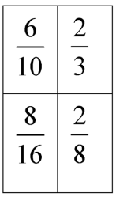 | Mr. Clark had 30 college football referrals to prepare. Of the 30 referrals, 22 of them were for young men. Write a fraction, in simplest terms, of the college referrals were for young men? | Cameron counted the cakes while waiting for her mother at the bakery. She noticed that 16 of the 20 cakes in the display case had chocolate icing. How would you express this fraction in its simplest terms? | Four friends ordered a 12-piece pizza to share. Bob ate 3 pieces. Write a fraction, in simplest terms, that shows how much Bob ate?

Wednesday (A.6.5.1)
Hedi and her family are going on a trip. The chart shows the amount of gas left in the tank as they travel.  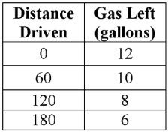  Based on the data, how many miles can they drive before they have no gas left? | Every time the Minzer family orders pizza for dinner, they order 1 slice per person and an extra 8 slices to put in the freezer for lunches throughout the week.  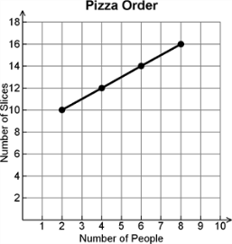  How many slices will the Minzer family order if they have 10 people eating dinner that night? | Elie’s parents have a house rule that for every minute Elie spends on the computer he must spend 3 minutes outdoors first. The chart below gives different amounts of time that Elie might want to spend on the computer, as well as the number of minutes of outdoor activity he needs to do to earn this computer time.  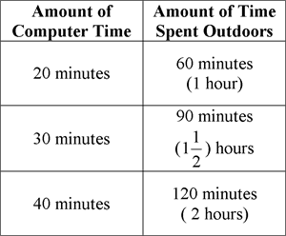  Based on this data, how much outdoor activity will Elie have to do to earn 90 minutes of computer time? | Charlene’s hair grows 1 inch every 2 months.  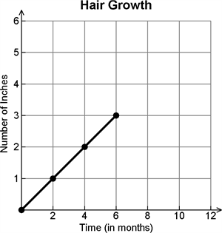  At this rate, how long will it take for Charlene’s hair to grow 5 inches?
Thursday (M.13.5.4b)
Kelsi and Rex want to buy their mom a new tablecloth for a small table. They have measured the table to figure out what size to purchase. What is the area of the table?  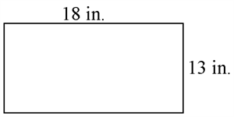 | Find the area of the figure below. | What is the area of the rectangle?  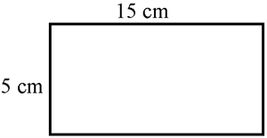 | The length of a rectangle is 24 inches. Its width is 12 inches. What is the area of the rectangle?

