Name________________ 5th Grade Math 4 Today Week #15
Monday (DAP.14.5.2)
What is the highest number recorded in their data set?  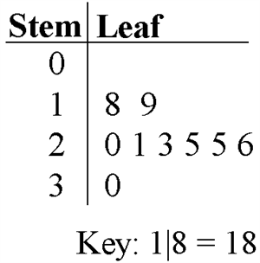 | What is the lowest number recorded in the data set? | Mrs. Adkins' fifth grade class created the following line plot about weights of dogs by surveying the students in their school. How many dogs weigh more than 17 pounds?  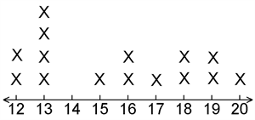 | Mrs. Adkins' fifth grade class created the following line plot about weights of dogs by surveying the students in their school. How many dogs weigh less than 15 pounds?
Solve each.  7 x 3 = | 4 x 8 = | 9 x 5 = | 4 x 6 =

Tuesday (A.6.5.1)
Look at this table:  Idaho crop prices per cwt  Crop 2003 2004  Canola $10 $11  Potatoes $4 $4  Onions $11 $7  Apples $20 $12  Peas $9 $7  Per cwt, how much did apples cost in 2004? | Look at this table:  Donations  Person Cancer research Job training  Michael $5 $6  Lazarus $13 $3  Ren $16 $17  Raylen $6 $17  Jedediah $20 $14  How much more money did Raylen donate to job training than Lazarus? | Look at this table:  Absences  Student 2007 2008  Dolf 14 11  Una 7 16  Fernand 15 7  Grayson 19 6  How many more absences did Dolf have in 2007 than Una?
Wednesday (A.5.5.1)
Solve the equation for w.  11−7=w | 3⋅c=135  What is the value of c? | What is the value of n in the equation below?  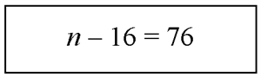

Thursday (G.9.5.1)
Which transformation is shown? | Which transformation of the letter A is shown? | Which of the following transformations is shown in the figure below?

