Name________________ 5th Grade Math 4 Today Week #7

Monday (NO.3.5.5b)
Jill and Anthony were playing a factor game. Jill selected the numbers 1, 2, 16, and 32 as factors of 32. Which factors did Jill miss? | What are the factors of 48? | What are all the common factors of 12 and 40? | Mark lists the following as factors of 128:  1 , 4 , 32 , 128  Which factors did Mark forget?
Solve each.  4 x 3 = | 6 x 4 = | 9 x 6 = | 7 x 8 =

Tuesday (A.5.5.3b)
Evaluate.  ( x + 4 ) − 2 if x=7 | Evaluate.  (23 × 3) + 21 – n if n = 50. | Evaluate.  (25 × 4) ÷ x if x = 20. | Evaluate.  12×2−x if x=10.

Wednesday (G.8.5.4)
Which line segment is congruent to AB?  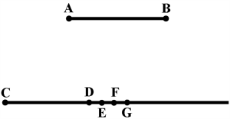 | Which of the following pairs of figures are not congruent?  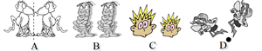 | Which of the following pairs of letters are not congruent?

Thursday (DAP.17.5.1)
Ms. Wood asked each student to write on a piece of paper one place that he or she would like to visit on a class field trip. The results are shown in the chart below.  Field Trip Choices  Places to Visit Number of Students Votes  science museum 9  water park 3  power plant 4  history museum 7  zoo 5  Ms. Wood placed each student’s paper in a bag and drew out a paper at random. What is the probability that she drew a piece of paper that had the science museum or water park written on it? | A box of crayons contains 3 reds, 4 blues, and 6 oranges. If a crayon is randomly drawn from the box, what is the probability that it is not blue? | Wayne has a number cube numbered 1 to 6. If he rolls the cube one time, what are the chances of him rolling either a 3 or a 4?

