Name_______________________ 5th Grade Math 4 Today Week #8
Monday (A.7.5.1)
Sandy mows lawns in her neighborhood every Saturday. She charges by the hour. If she mows 6 lawns in 8 hours, she can earn $32. What does she charge per hour? | At an average speed of 60 miles per hour, about how long will a 420-mile trip take? | Old Faithful erupts once every 76 minutes.  Eruptions 1 2 3 4  Minutes 76 152 228 304  How many times does Old Faithful erupt in  608 minutes? | The 7215 Forgrove Candy Machine can slice and wrap 450 pieces of candy per minute. At this rate, how long would it take to slice and wrap 4,500 pieces of candy?  Time (in minutes) 1 2 3 4  Pieces Sliced and Wrapped 450 900 1,350 1,800
Solve each.  6 x 6 = | 3 x 9 = | 4 x 7 = | 8 x 9 =

Tuesday (G.9.5.1)
Which transformation is represented in the figure below?  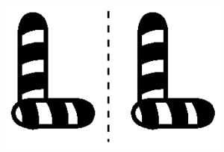 | Salma laid a banana on her desk before recess. When she came back after recess, the banana had been moved.  Which type of transformation had been made? | Which white triangle shows a translation (slide) of the black triangle? 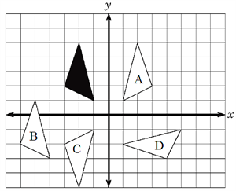

Wednesday (M.12.5.4b)
Kyle’s dad wants to put carpet in Kyle’s bedroom. He measures to find how many square feet the floor is in order to buy the carpet he needs. What is Kyle’s dad measuring? | Central Middle School art students are helping to paint a mural in the city park. The figure below shows the space they have been assigned to paint.  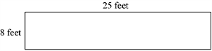  What is the area the students will paint? | Maggie is saving her money to buy a piece of carpet for the floor of her playhouse. Maggie’s playhouse is 10 feet long and 12 feet wide. How much carpet will Maggie need to purchase to cover the floor of her playhouse? | What is the area of the rectangle?  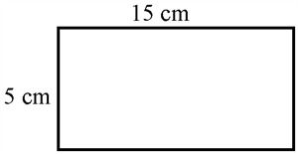

Thursday (NO.1.5.1c)
Find a solution to the open sentences below.  42 ÷ n = 6  56n = 7 | Three friends are sharing 2 cupcakes.  How many thirds will each friend get? | Four friends are sharing 2 brownies.  How many fourths will each friend get?

