Name_________________________ 5th Grade Math 4 Today Week #9
Monday (G.11.5.1)
Kylee drew the net below.  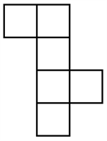  If she folded the net, which three-dimensional figure would result? | Joel is drawing a net that can be folded to make a cube. So far he has drawn Figure 1.  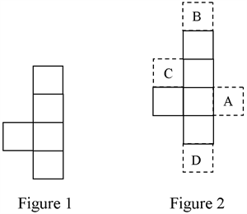  He needs to draw one more square to complete his net. Where should he draw it? | Why will this net not make a cube?  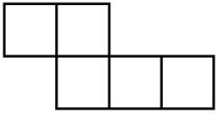
Solve each.  7 x 3 = | 5 x 7 =  6 x 8 = | 2 x 9 =  9 x 4 =

Tuesday (M.13.5.6)
Shayne and his dad are racing their sailboat next month. They plan to spend this weekend practicing the course laid out in the competition information packet. The most difficult turn is shown below.  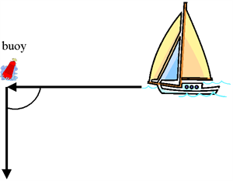  What is the size of the angle that needs to be made at the buoy marker? | What is the best estimate of ∠ABC?  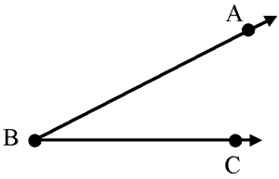 | Mr. Looper, the Boy Scout leader, is laying out an orienteering course for his troop. He needs them to make the turn shown below. Give the angle name for the turn indicated.  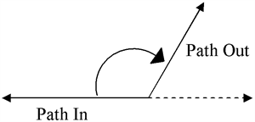 | What is the name of ∠ADC?  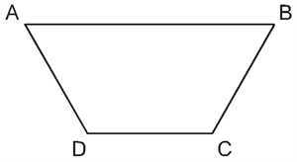

Wednesday (DAP.15.5.1a)
Jody charted the growth of her new kitten. Between which two weeks did Smoky, the kitten, grow the fastest?  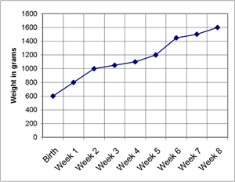 | Rhonnie recorded her daily walk on the graph below.  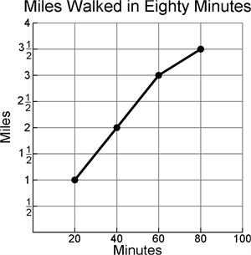  How far did she walk in the last 20 minutes? | During a 7-week computer skills course, Gabriela charted her typing speed at the end of each week. Between which two weeks did Gabriella’s typing speed improve the least?  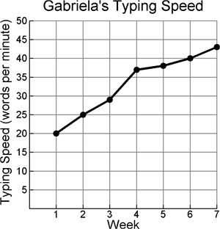 | Mr. Rosenberg’s class is taking part in the Buffalo River Clean-Up Project. Mr. Rosenberg tracks the total number of hours his students help at the river each day.  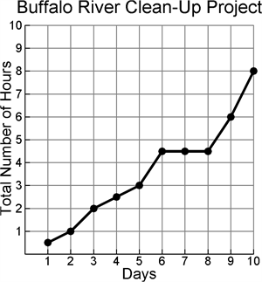  A thunderstorm prevented Mr. Rosenberg’s class from participating two of the days. On which days did the thunderstorm occur?

Thursday (A.5.5.2)
LaJuan has 13 more videos in his collection than Antonio. If v equals the number of Antonio's videos, write an expression to represent the number of videos that LaJuan has? | Solve for x.  1,624 – x = 569 | Jamie gets $3 more a week for her allowance this year than last. If a is her allowance last year, write an expression that shows the amount of allowance she gets now? | Solve for n.  636 + n = 1,703

