|  |  |  |  |
| --- | --- | --- | --- |
| **Week 12 Sixth Grade Math For Today Name: ______________________** | | | |
| **DAP.15.6.1**  **Interpreting Graphs-Double Line** | | **NO.3.6.2**  **Computational Fluency - Decimals** | **G.8.6.4**  **Circle Parts and Formulas** |
| **M**  **O**  **N**  **D**  **A**  **Y** | How many days was the average daily temperature in May higher in 1995 than in the same day in 2005? | |  |  | | --- | --- | | **Weights of Some Mammals** | | | **Animals** | **Weight in Pounds** | | Lion | 400.6 | | Gorilla | 437.8 | | Tiger | 250.17 |   Use the table above to calculate the total weight of 2 lions, 2 gorillas and 1 tiger.  Show all of your work. |  |
| **T**  **U**  **E**  **S**  **D**  **A**  **Y** | Use the graph from Monday to answer the following:   1. How many days was the average daily temperature in May lower in 1995 than in the same day in 2005? 2. What was the approximate difference in the average daily temperatures for the two years on May 17? | Use the table from Monday to answer the following:   1. What is the difference between the weight of a tiger and the weight of a gorilla? 2. How many more pounds does a lion weigh than a gorilla? | Calculate the circumference of each circle with a given radius. Use 3.14 for pi.   1. Radius = 4 cm 2. Radius = 6 in 3. Radius = 5 ft 4. Radius = 10 mm |

|  |  |  |  |
| --- | --- | --- | --- |
| **Week 12 Name: ______________________** | | | |
| **Sixth Grade Math For Today** | | | |
| **W**  **E**  **D**  **N**  **E**  **S**  **D**  **A**  **Y** | According to the graph above, what was the value of Kirk Kicker’s card in April? | MC900410803[1]  Jody needs to buy 18 yards of material for costumes. If each yard of material costs $4.79, what is the total cost for the material?  Show all of your work. | C:\Documents and Settings\Sharlene.Evans\Local Settings\Temporary Internet Files\Content.IE5\OTY3OHA7\MC900319436[1].wmf  A tire has a diameter of 20 inches. Approximately how far will the tire travel in one complete revolution? |
| **T**  **H**  **U**  **R**  **S**  **D**  **A**  **Y** | Use the graph from Wednesday to answer the following:   1. In which month was the difference in value between Kirk Kicker’s and Russell Runner’s card the greatest? 2. What was the combined value of their cards in March? | Autumn bought 8 yards of material for costumes and spent a total of $33.20. How much did each yard of material cost?  Show all of your work. | C:\Documents and Settings\Sharlene.Evans\Local Settings\Temporary Internet Files\Content.IE5\GLANO1UV\MC900432143[1].wmf  A coin has a diameter of one inch. Approximately how far will the coin travel in 10 complete revolutions? |

**Name:________________________________**

|  |
| --- |
| **6th Grade Friday Math for Today** |

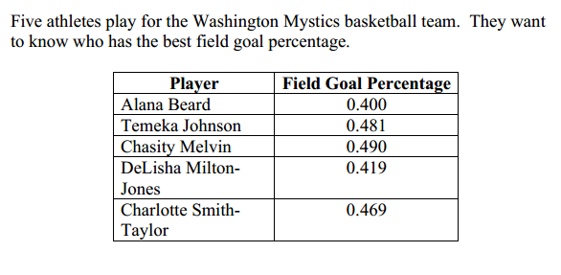

1. Place their field goal percentages in order from greatest to least.
2. Use what you know about the place value of decimals to explain why your answer is correct. Use numbers and words in your explanation.