Week 13 Sixth Grade Math For Today Name: ______________________
DAP.15.6.1  Interpreting Graphs-Double Bar |  | A.5.6.2  Write Algebraic Expressions in One Variable | M.13.6.3  Draw/Measure to Nearest 1/8 inch
M  O  N  D  A  Y | 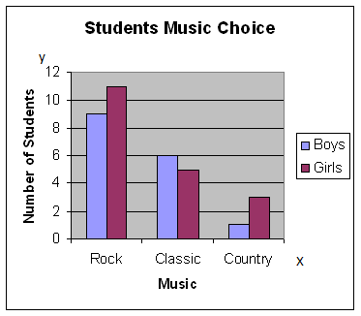  How many students were surveyed in the graph above? | The length of a rectangular flower garden is triple its width. If w represents the garden’s width, write an expression to represent the length.  Alice is four years older than Kate. If  K stand for Kate’s age, write an expression that would be used to find Alice’s age. | A portion of a tape measure is shown below. Find the total length of each grey bar.  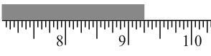  A. ________________ inches  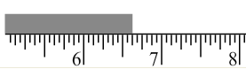  B. ________________inches
T  U  E  S  D  A  Y | 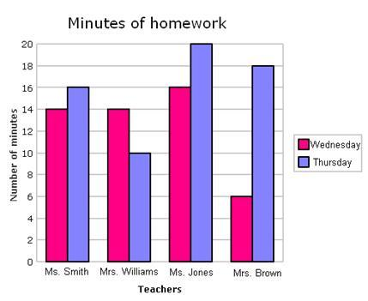On Wednesday, how many more minutes of homework did Ms. Jones give than Ms. Brown? | Jon earned $50 more than Nathan this summer mowing lawns. If N represents the money Nathan earned, write an expression to represent Jon’s earnings.  Sam and Tom each earned the same amount of money raking leaves. If together they earned a total of T dollars, write an expression could be used to find Sam’s earnings. | 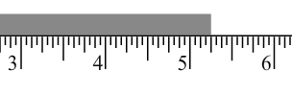  - _________________inches  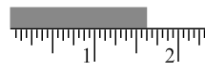  - ________________inches

Week 13 Name: ______________________
Sixth Grade Math For Today
W  E  D  N  E  S  D  A  Y | 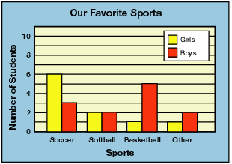  Use the graph to answer the following.  - What was the favorite sport of boys?  - What was the favorite sport of girls?  - What is the ratio of boys surveyed to girls surveyed? | Shane’s basketball team played 36 games last year. If w stands for the number of games they won, write an expression for the number of games the team lost.  Today Mrs. Cole baked double the number of cookies she made last week. If last week she made C number of cookies, what expression would represent the amount she baked this week? | 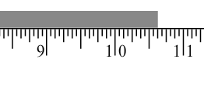  - _______________ inches  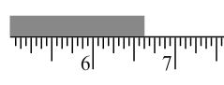  - _______________inches
T  H  U  R  S  D  A  Y | 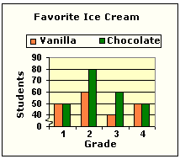  Write the ratio of students who like vanilla ice cream to students who like chocolate ice cream in 2nd grade_______________  and 3rd grade_____________  Which ratio is greatest?___________________ | Suppose R stands for Randy’s age. Write an expression that would tell Randy’s age five years ago.  Suppose Mrs. Smith’s age is Y years old and her daughter, Autumn, is one-third of her age. Write an expression that would tell Autumn’s age. | 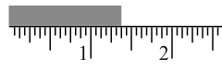  - ______________ inches  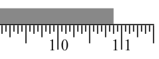  - ______________inches

6th Grade Friday Math for Today – DAP.15.6.1, 14.6.3
Student Food Drive

London School had a contest between the boys and the girls in the 5th grade classes. They were trying to see which class brought in the most number of canned foods for the Christmas Food Drive.

Classes girls boys
Mrs. Goodin 48 23
Mrs. Hedrick 44 30
Mrs. McWhorter 38 23
Mr. Weaver 39 36

  - Construct a double bar graph that will display the data listed above concerning the London School Canned Food Drive.
(Hint: Remember to label all parts of a graph)

  - Analyze the information on your graph. According to your findings, which 5th grade class, boys and girls together, collected the most cans?

C. Were more total cans of food collected by all the boys or by all
the girls? What is the difference in the total amount of cans
the girls collected in comparison to the total number of cans the
boys collected?

D. List the teachers’ names in order from least total cans collected to the
greatest total number of cans collected.

