Week 20 Sixth Grade Math For Today Name: ______________________
G.8.6.2a  Changes in Perimeter When Dimensions Change |  |  |  | M.13.6.4  Formulas for Area and Perimeter |  | A.4.6.1  Missing Term in Pattern or Function Table
M  O  N  D  A  Y | 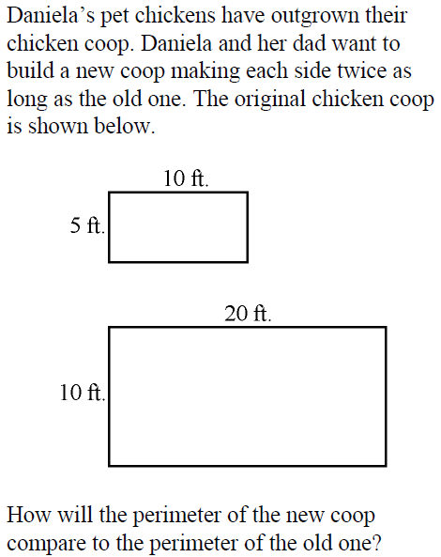 |  | 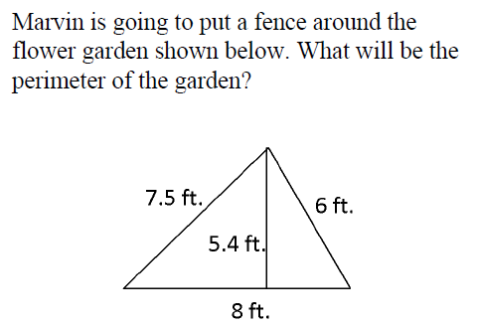 |  |  | BLAST FROM THE PAST: Remember these problems from Weeks 1 and 3?
What is the missing term in the following pattern?

1, 3, 5, ___, 9, 11…

Juan had the following number of stolen bases in each of his first five years in Little League:

4, 9, 14, 19, 24

If the pattern continues, how many will Juan have in his 6th year?
T  U  E  S  D  A  Y | 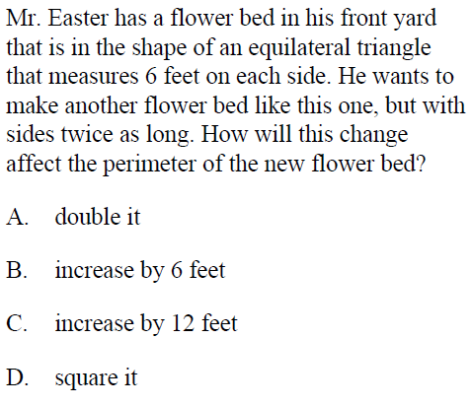 |  | If one side of an equilateral triangle measures 6 cm, what is the perimeter of the triangle? |  |  | If you continue the pattern below, how many  blocks would you shade in the last square?  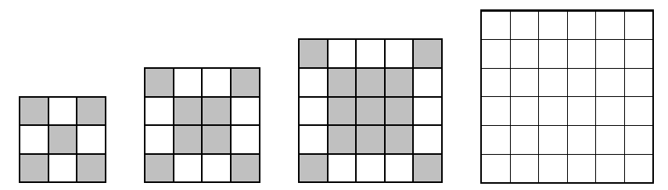
 |  |  | If the perimeter of a square is 16 inches, what is the length of one side of the square?
Week 20 Name ______________________
Sixth Grade Math For Today
W  E  D  N  E  S  D  A  Y | 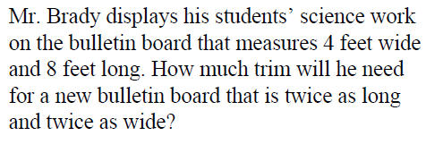  Show all of your work. | What is the perimeter of a rectangle with a length of 4 feet and a width of 5 feet? |  |  | What is the eighth term in the counting sequence below?  106, 98, 90, 82 …
 |  | A rectangle has a perimeter of 24 inches. Its length measures 8 inches. What is the measure of its width? |  |  | Find the next number in the sequence.  1080, 360, 120, ____
T  H  U  R  S  D  A  Y | 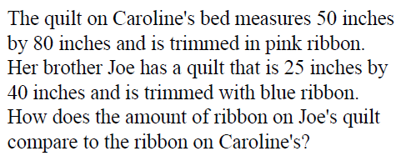  Show all of your work. | 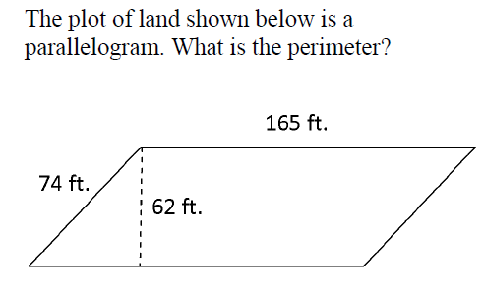 |  |  | The local bakery is complete mayhem! The oven seems to be broken. When cookies go in the oven, fewer cookies come out. Below is a table of the outcomes when cookies go in the oven. What are the missing values?  In Out  38 33  32 ?  28 23  24 ?  20 15  16 ?

6th Grade Friday Math for Today
MATHEMATICS OPEN-RESPONSE ITEM A NO.3.6.3

