Mathematics CFA Template
Pre-Instruction
1. List the Standard. Underline the nouns (what students will know) and highlight the verbs (what student will do):
8.G.7 Apply the Pythagorean Theorem to determine unknown side lengths in right triangles in real-world and mathematical problems in two and three dimensions.
2. Mathematical Practices
SMP 1. Make sense of problems and persevere in solving them.
SMP 2. Reason abstractly and quantitatively.
SMP 4. Model with mathematics.
SMP 6. Attend to precision.
3. I Can Statements – Put learning targets in student friendly terms.
I can apply the Pythagorean theorem to determine the side lengths in a right triangle.

Depth of Knowledge of the standard (Highlight the Level of the Learning Target):
Level 1 Recall; Level 2 – Skill/Concept; Level 3 – Strategic Thinking; Level 4 – Extended Thinking
4. List the skills students need to know in order to begin this standard:
What is a right triangle.
Solve two step equations.

5. What type of assessment am I going to write? [selected response (m/c, t/f, y/n, matching, fill in ___) or constructed response (short: word, phrase, sentence, single problem; extended: multi-step operations in math, problem solving)] List the assessment questions.
Constructed Response
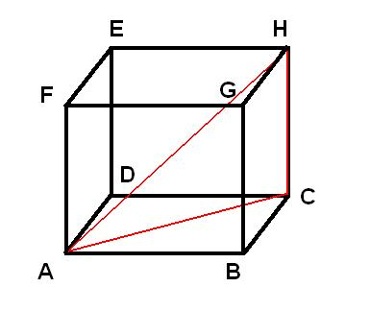
Line AB = cm
Line AC = 22 cm

Using the Pythagorean Theorem determine the length of line BC.

Line AC = 22 cm
Line HC = 20 cm
Using the Pythagorean Theorem determine the length of line AH.

6. Scoring Guide
Exceeds Expectations:
Proficient: Correctly answers all questions.
Approaching Proficiency: Correctly answers one of the two problems.
Not Proficient: Fails to answer questions correctly.

