Name_________________ 5th Grade Math 4 Today Week #13

Monday (G.9.5.1)
Donavan used cardboard to make a design that he could trace onto his t-shirt. He placed the design on the t-shirt, but didn’t like the way it looked, so he changed the position. Study Donovan’s shirt below.  Which transformation did he make with his design? | Which kind of transformation is demonstrated in the figures below?  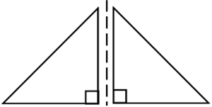 | Which transformation could have been used to produce Part B of the picture?  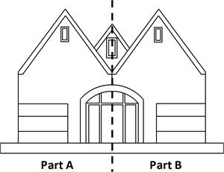 | Which transformation is shown?  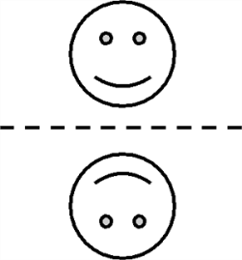
Solve each.  4 x 6 = | 5 x 9 = | 7 x 3 = | 6 x 7 =

Tuesday (A.5.5.1)
Solve for n.  6×(4+4)12=n | What is the value of n in the equation below?  n÷20=40 | Find the value of n.  25+(n+14)=53 | Find the value of n.  (n×2)+26=50

Wednesday (M.13.5.4a)
Mrs. Conner is making a bulletin board for her science classroom. She has 8 feet of border to put around the board. If the size of the bulletin board is 4 feet by 5 feet, how much more border will she need? | Jo Ann's vegetable garden is being raided by rabbits. She has decided to put a fence around it to keep them out. The length of the garden is 12 ft and the width is half the length. How much fence will Jo Ann need to go around the garden? | What is the perimeter of the figure below?  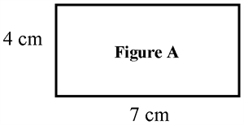 | Each side of a square is 6 inches.  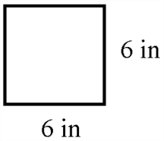  What is the perimeter?

Thursday (A.5.5.2)
Solve for x.  1,624−x=965 | Find the missing addend:  9+p+6=23 | Solve for n.  802−n=167 | Solve for n.  636+n=1,903

