Name____________________ 5th Grade Math 4 Today Week #16
Monday (A.5.5.3b)
Evaluate.  ( x + 4 ) − 2 if x=17 | Evaluate.  (23 × 3) + 21 – n if n = 30. | Evaluate.  (25 × 4) ÷ x if x = 10. | Evaluate.  12×2− x if x=20.
Solve each.  6 x 3 = | 7 x 9 = | 8 x 4 = | 8 x 8 =

Tuesday (G.8.5.4)
Which line segment is congruent to AB?  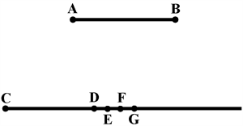 | Which of the following pairs of figures are not congruent?  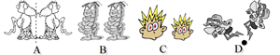 | Which of the following pairs of letters are not congruent?
Solve each.  9 x 9 = | 4 x 7 = | 7 x 6 =

Wednesday (NO.3.5.5b)
Jill and Anthony were playing a factor game. Jill selected the numbers 1, 2, 16, and 48 as factors of 48. Which factors did Jill miss? | What are the factors of 28? | What are all the common factors of 15 and 40? | Mark lists the following as factors of 128:  1 , 4 , 32 , 128  Which factors did Mark forget?
Solve each.  4 x 3 = | 6 x 4 = | 9 x 6 = | 7 x 8 =

Thursday (M.13.5.1)
The time is 4:40 p.m. What time will it be in 1 hour and 30 minutes? | The time now is 10:45 a.m. Lee needs to leave in an hour and 15 minutes. What time does he need to leave? | Zeke went camping for a night. He arrived at the campground at 5:05, and left 15 hours and 55 minutes later. What time was it when Zeke left the campground? | Stephen's band rehearsal started at twenty-five past three and was two hours and thirty minutes long. What time was it when Stephen's rehearsal ended?
Solve each.  5 x 3 = | 6 x 8 = | 9 x 5 = | 7 x 7 =

