Name_______________ 5th Grade Math 4 Today Week #17
Monday (DAP.17.5.1)
Carl’s favorite part of camping is going out in a canoe. The camp has 6 red canoes and 8 green canoes. If Carl is randomly assigned a canoe, what is the probability that he will be assigned a red canoe? | What is the probability that the spinner shown below will land on an even number?  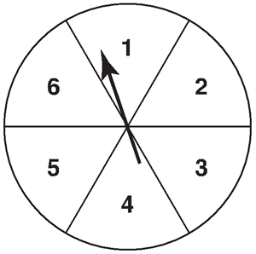 | Hannah is playing a game with Ian. They are using a six-sided number cube with its faces labeled with the numbers 1 to 6. To win, Ian must roll a prime number. What is the probability of Ian winning the game? | There are 8 boys and 7 girls in Mrs. Camden’s music class. To pick a student to play the new keyboard, she plans to put everyone’s name in a bag. What is the probability that a girl’s name will be randomly picked?
Solve each.  4 x 4 = | 9 x 9 = | 5 x 5 = | 7 x 7 =

Tuesday (M.13.5.4b)
Kelsi and Rex want to buy their mom a new tablecloth for a small table. They have measured the table to figure out what size to purchase. What is the area of the table?  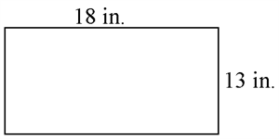 | The playroom at the YMCA needs a new floor. Darlene measured the room and figured the area to be 2,128 square feet. Later, when she drew a diagram of the room, she could not remember the width of the room. What is the width of the playroom?  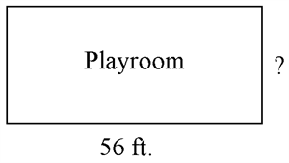 | Jack and his mother are putting a new flowerbed in the front yard. They need to add top soil and fertilizer to prepare the ground for flowers. If the flowerbed measures 2 feet wide and 6 feet long, what is the area of ground it covers? | What is the area of the rectangle?  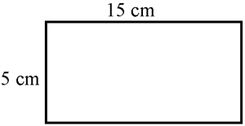
Solve each.  4 x 9 = | 8 x 7 = | 5 x 8 = | 7 x 3 =

Wednesday (NO.1.5.1e)
The ceiling in the math room has some dark tiles and some white tiles in it. What percent of the ceiling are dark tiles? | Out of 100 students 80% of them wear athletic shoes to school. How many students do not wear athletic shoes? | At the last orchestra concert, 40 out of 100 musicians were violinists. What percent of the musicians were violinists? | Which percent value is represented by the diagram below?
Solve each.  5 x 3 = | 6 x 9 = | 8 x 6 = | 4 x 3 =

Thursday (A.5.5.2)
Anthony is the youngest child in his family. He is 7 years younger than his sister Nikki. If  n = Nikki’s age, write an expression that can be used to find Anthony’s age? | LaJuan has 13 more videos in his collection than Antonio. If v equals the number of Antonio's videos, write an expression to represent the number of videos that LaJuan has? | The fifth grade students are collecting canned food for the food bank. Mrs. Geoffrey’s class has collected 27 more cans than Mr. Nico’s class. If n = the number of cans Mr. Nico’s class has collected, write an expression that can be used to represent the amount of cans Mrs. Geoffrey’s class has collected? | Sara grew 3.8 inches since last year. If h is her height now, write an expression that shows her height last year?
Solve each.  6 x 4 = | 9 x 5 = | 8 x 5 = | 3 x 8 =

