Mathematics CFA Template
Pre-Instruction
1. List the Standard. Underline the nouns (what students will know) and highlight the verbs (what student will do):
  - 6.EE.9.Use variables to represent two quantities in a real-world problem that change in relationship to one another; write an equation to express one quantity, thought of as the dependent variable, in terms of the other quantity, thought of as the independent variable. Analyze the relationship between the dependent and independent variables using graphs and tables, and relate these to the equation. For example, in a problem involving motion at constant speed, list and graph ordered pairs of distances and times, and write the equation d = 65t to represent the relationship between distance and time.
2. Mathematical Practices
    - Make sense and preserver in solving problems
    - Reason abstractly and quantitatively
    - Construct viable arguments and critique the reasoning of others
    - Model with mathematics
    - Use appropriate tools strategically
    - Attend to precision
    - Look for and make use of structure
    - Look for and express regularity in repeated reasoning
3. I Can Statements – Put learning targets in student friendly terms.
  - I can write expressions using variables to represent two quantities that change in relationship to one another.
  - I can write equations to express dependent and independent variables.
  - I can recognize analyze the relationship between the dependent and independent variables using graphs and tables.
Depth of Knowledge of the standard (Highlight the Level of the Learning Target):
Level 1 Recall; Level 2 – Skill/Concept; Level 3 – Strategic Thinking; Level 4 – Extended Thinking
4. List the skills students need to know in order to begin this standard:
    - Read and understand/make sense of word problems
    - Write and interpret numerical expressions (5.0 A.1,2)
    - Understand patterns and relationships (5.0 A .3)
    - Write and evaluate numerical expressions involving whole numbers. (6.EE.1)
    - Write, read, and evaluate expressions in which letters stand for numbers. (6.EE.2)
    - Apply the properties of operations to generate equivalent expressions. (6.EE.3)
    - Identify when two expressions are equivalent (i.e. when the two expressions name the same number regardless of which value is substituted into them).(6.EE.4)
    - Understand solving an expression or inequality as a process of answering a question. (6.EE.5)
    - Use variables to represent a number and write expressions when solving real-world or mathematical problem; understand that a variable can represent an unknown number, or any number in a specified set. (6.EE.6)
    - Solve real-world or mathematical problem by writing and solving equations of the form x + p = q, and px = q, where p, x, and q are all nonnegative rational numbers.(6.EE.7)
    - Write an inequality of the form x > c or x < cto represent a constraint or condition in a real-world or mathematical problem.(6.EE.8)
    - Vocabulary: base, exponent, expression, equation, evaluate, independent/dependent variables, inequality
5. What type of assessment am I going to write? [selected response (m/c, t/f, y/n, matching, fill in ___) or constructed response (short: word, phrase, sentence, single problem; extended: multi-step operations in math, problem solving)] List the assessment questions.
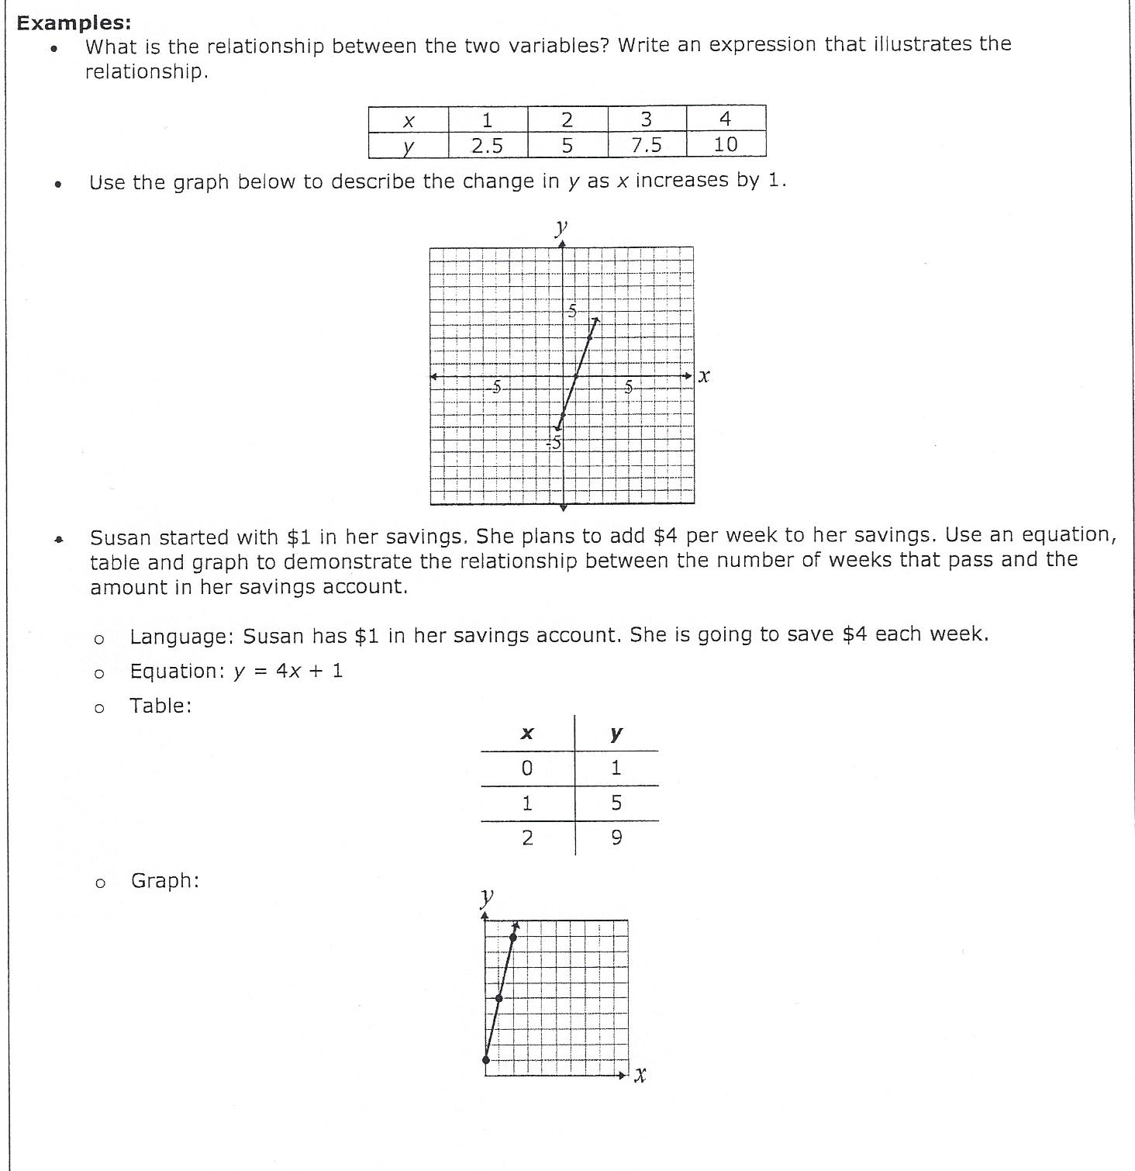

6. Scoring Guide
Exceeds Expectations: Student correctly answered all questions and included notes or explanations.
Proficient: Student answered correctly for all material aspects of the question.
Approaching Proficiency: Student answered correctly for some material aspects of the question.
Not Proficient: Student could not correctly answer for any material aspects of the question.

