Week 18 Sixth Grade Math For Today Name: ______________________
DAP.16.6.1  Data Inferences |  |  |  | G.10.6.2  Plot Vertices and Classify Figures |  | NO.3.6.3  Multi-Step Problems
M  O  N  D  A  Y | A safety committee ranked roller blades for safety and quality as shown in the chart below.  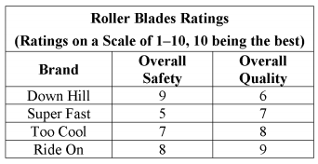  Which brand scored lowest overall for safety and quality? Explain. |  | 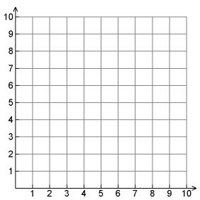  What figure is formed by connecting the points (4, 0), (2, 5), (6, 5), and (4, 0)? Be as specific as possible. |  |  | Blake charges $12 an hour to mow lawns. He mows lawns A, B and C once every week. Lawn A takes 2 hours to mow, Lawn B takes 2 ½ hours to mow, and lawn C takes 3 ½ hours to mow. How much money does he make mowing lawns every week?
T  U  E  S  D  A  Y | 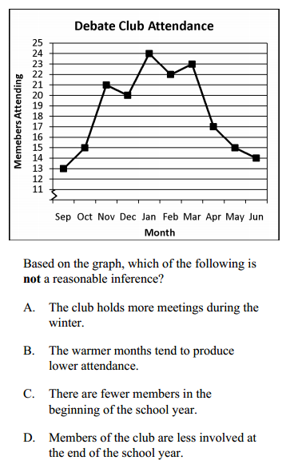 |  | 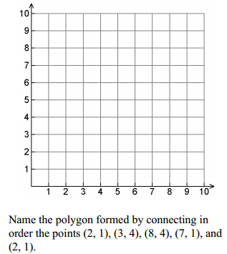 |  |  | 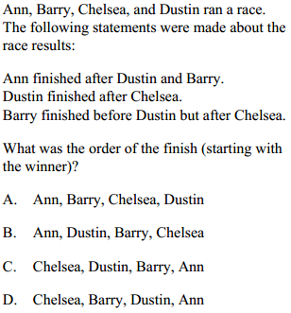
Week 18 Name: ______________________
Sixth Grade Math For Today
W  E  D  N  E  S  D  A  Y | Zach graphed the miles he drove in 8 days.  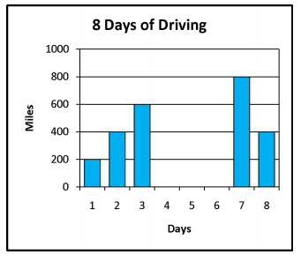  What reasonable inference can be made from this data?  A. Zach is a doctor B. Zach likes to drive  C. Zach is on vacation D. Zach delivers pizza. | 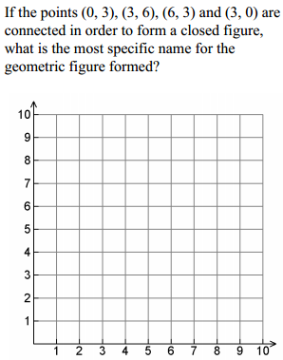  A. parallelogram B. rhombus  C. square D. trapezoid |  |  | 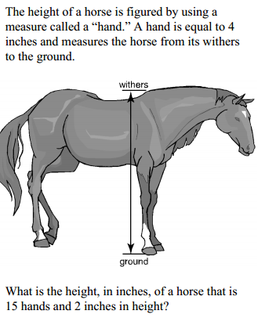
T  H  U  R  S  D  A  Y | 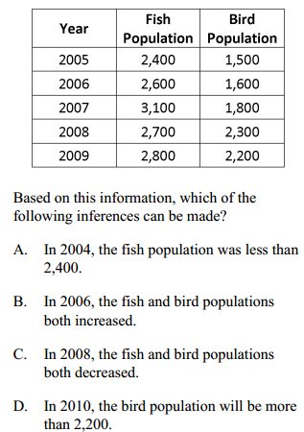 | Classify the triangle formed when points (3,1), (3,7) and (6.7) are connected.  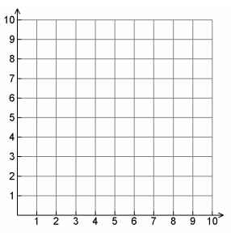 |  |  | There are 70 fifth graders and 50 sixth graders at Amelia Middle school.  If 1/5 of each class participated in summer camp, how many fifth and sixth graders were in the school’s summer camp?

6th Grade Friday Math for Today
MATHEMATICS OPEN-RESPONSE ITEM A NO.3.6.3

