Mathematics CFA Template
Pre-Instruction
1. List the Standard. Underline the nouns (what students will know) and highlight the verbs (what student will do):
8.EE.8 Analyze and solve pairs of simultaneous linear equations b.) Solve systems of two linear equations in two variables algebraically, and estimate solutions by graphing the equations. Solve simple cases by inspection.

2. Mathematical Practices
SMP 1. Make sense of problems and persevere in solving them.
SMP 4. Model with mathematics.
3. I Can Statements – Put learning targets in student friendly terms.
I can solve two linear equations with two variables.
I can estimate solutions by graphing the equations.
I can solve by inspection.

Depth of Knowledge of the standard (Highlight the Level of the Learning Target):
Level 1 Recall; Level 2 – Skill/Concept; Level 3 – Strategic Thinking; Level 4 – Extended Thinking
4. List the skills students need to know in order to begin this standard:
Know the parts of and be able to graph slope intersect form.
Be able to solve mutli-step equations with more than one variable.

5. What type of assessment am I going to write? [selected response (m/c, t/f, y/n, matching, fill in ___) or constructed response (short: word, phrase, sentence, single problem; extended: multi-step operations in math, problem solving)] List the assessment questions.
Constructed Response
- Solve the two linear equations algebraically.
3x – 2y = 6
x – y = 1
- Solve the two linear equations by graphing.
x + y = 5
-x + 3 = y
3. Determine the solution of the two linear equations below.
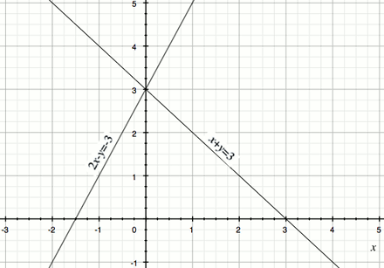

6. Scoring Guide
Exceeds Expectations:
Proficient: Correctly responds to all problems.
Approaching Proficiency: Correctly answers two out of three questions.
Not Proficient: Correctly answers one of the three questions.

